HUMBLE SIGN
DESIGN TO BUILD
PROCESS FLOW DOCUMENT

Roles:
A role is a configuration assigned to a user, which defines what an individual can see and do in the NetSuite system. In other words, a user's role is restricted by the permissions associated with that role. Depending on the role(s) assigned, a user can get access to different data and perform various actions within the system, and to find their role, they can simply need to look at the top right corner of the NetSuite screen.
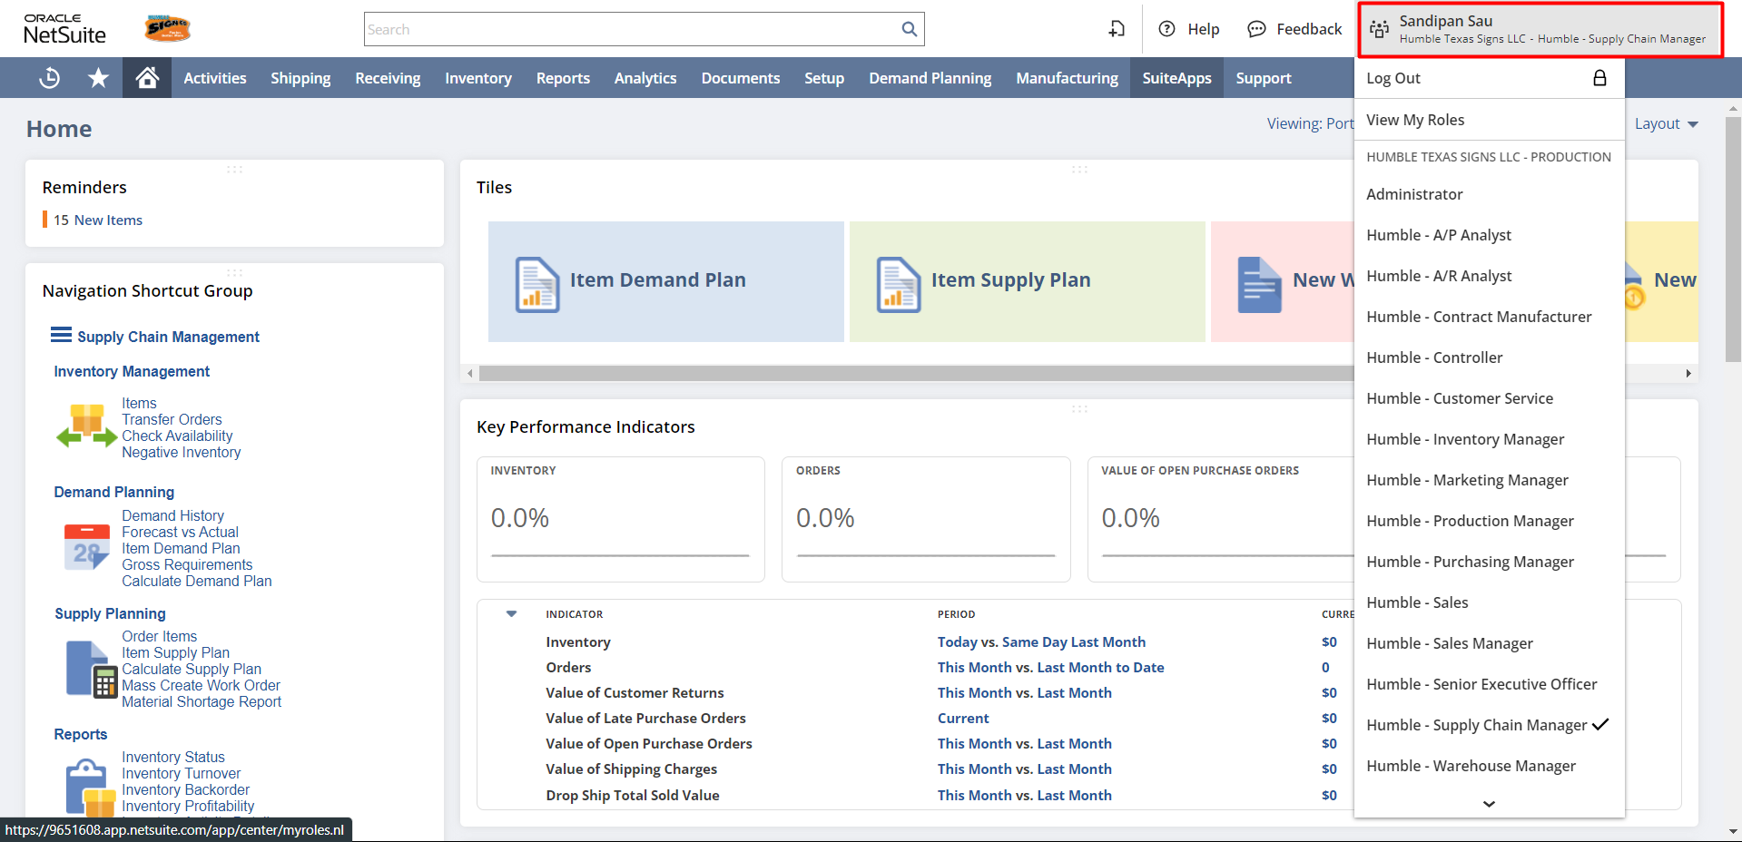
Also, if a user is assigned multiple roles, they can switch roles by clicking on the desired role.
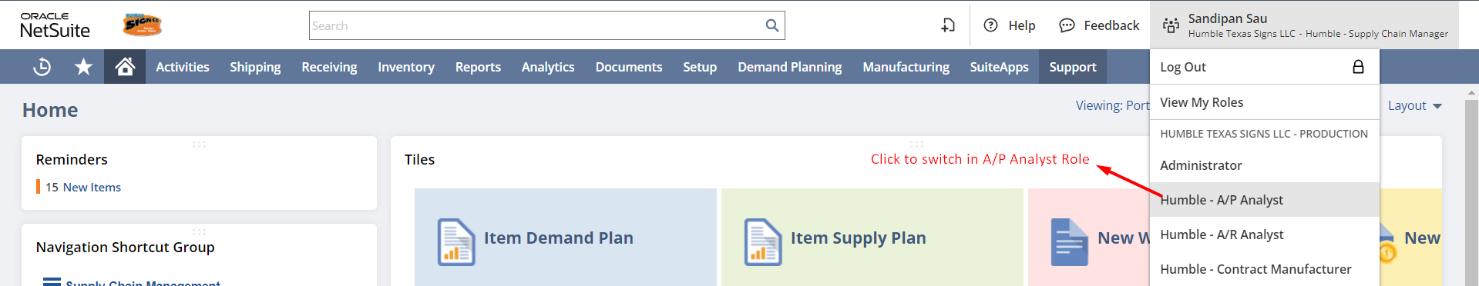

Login to Role: Supply Chain Manager
Items Types:
Step 1: To View all types of Item present in NetSuite navigate to Inventory -> Lists -> Items -> New.
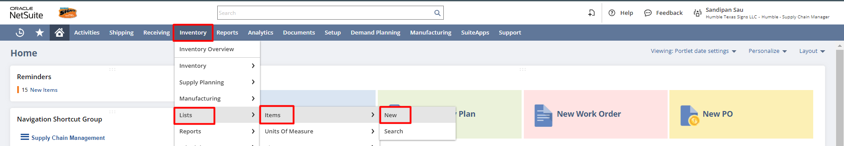

Step 2: A list of item types will be open.

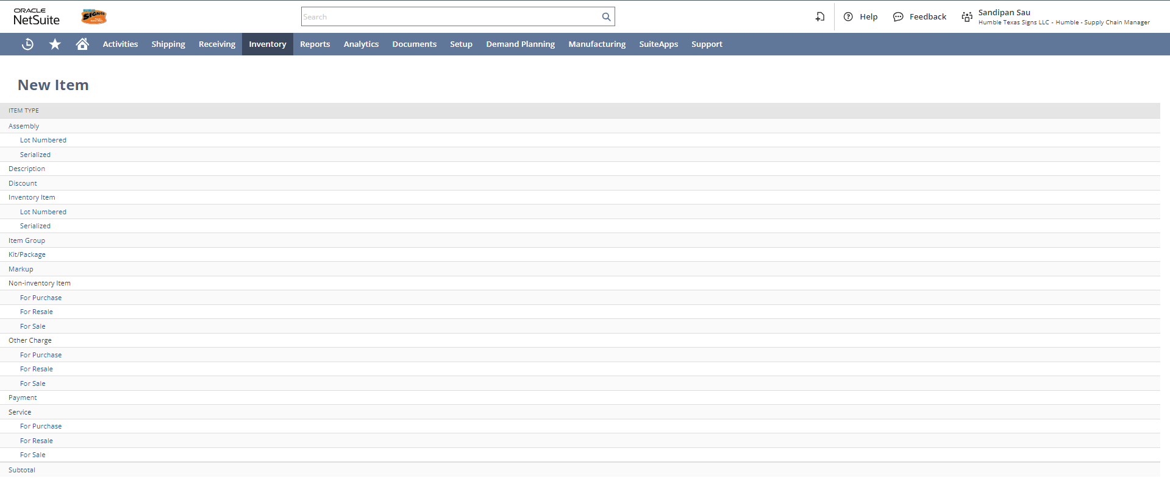

Assembly Item: In NetSuite, an item that is manufactured and consumes other components as part of that process is called an Assembly Item. Assembly Items can optionally be defined as lot numbered or serialized.
  - Lot Numbered Assembly: the assembly items that recognized in batches.
  - Serial Number Assembly: where each individual assembly item has a unique number.

Description Item: Description line items let you place sentence-or paragraph-long descriptions on items you are not selling. For example, you can enter special shipping instructions or a disclaimer. Description items have no amount field. They are only used to add text to transactions. They can be used on both purchase and sales transactions.

Discount Item: It is used in sales transactions to apply discounts to the items being sold. Let’s say you 10%.
When a discount item is applied on a sale, it reduces the line-item amount that precedes the discount item by a percentage or flat rate. A discount item can also be used to reduce the total amount of a transaction.

Inventory Item: NetSuite inventory item records let you track the quantity and value of your inventory. Your balance sheet automatically reflects the value of your inventory on hand, and your income statement automatically reflects the mark-up you charge for these items.
  - Lot Numbered Inventory Item: the inventory items that recognized in batches.
  - Serial Number Inventory Item: where each individual inventory item has a unique number.

Group Item: An item group is sold as a single unit, but made up of several individual items. An item group is a group of items on a sales or purchase order that need to be sold or purchased together. The item group is not fulfilled, received, or stocked. The components of the group are. However, the item group is available in the item list on a sales or purchase order and can be added to those transactions.

Kit/Package Item: Kits or packages let you create items that are collected from other items. You can assign multiple price levels to your kits and even make them available in your website. Whenever you sell a kit, inventory items are deducted from inventory.

Markup Item: You can use mark-up items to apply an additional charge to an order. Using markup items lets you track markup amounts without affecting inventory valuation. For example, you can charge a rush fee for completing a service or delivering an item quicker than is usually guaranteed.

Non–Inventory Item: A non-inventory item is something that a company purchases for its own use but does not track in terms of quantity. The following are examples of non-inventory items:
- Non-inventory Items for Sale – can be bought, sold, and consumed but are not added to a purchase order or kept in inventory. Non-inventory items for sale can only be sold to customers and entered on customer-facing transactions, such as sales orders, cash sales, or invoices.
- Non-inventory Items for Purchase – can only be bought and entered on vendor-facing transactions such as purchase orders and vendor bills. These items are purchased by your organization but not resold, such as office supplies.
- Non-inventory Items for Resale – can be bought and sold and appear on all applicable transaction types. This includes drop-ship items that you do not store but sell directly from the vendor.

Other Charge Item: Other charge items can be used to designate items or services you purchase or sell that do not fall into another type of item. For example, you might use other charge items in the following ways:
- Other Charge for Sale – to charge for gift wrapping or alterations.
- Other Charge for Purchase – when your company must pay a vendor a rush charge.
- Other Charge for Resale – when you receive free boxes with a wholesale purchase but sell the boxes for a profit.

Service Item: A service item is an item you create to track time and record billable hours. Service items are classified as Services for Purchase, Services for Resale, or Services for Sale. Services for Purchase.
- Services for Purchase – services your business buys but doesn't sell to customers.
- Services for Resale – services your business buys and then sells to customers.
- Services for Sale – services your business sells but doesn't buy.

Subtotal Item: Subtotal item records are used to separate groups or individual line items if you want to offer a discount or tax on certain line items but not others.
Inventory Item Creation:
To create a new Inventory Item go to the New Item Creation list ( Inventory -> Lists -> Items -> New ) and select the Inventory Item
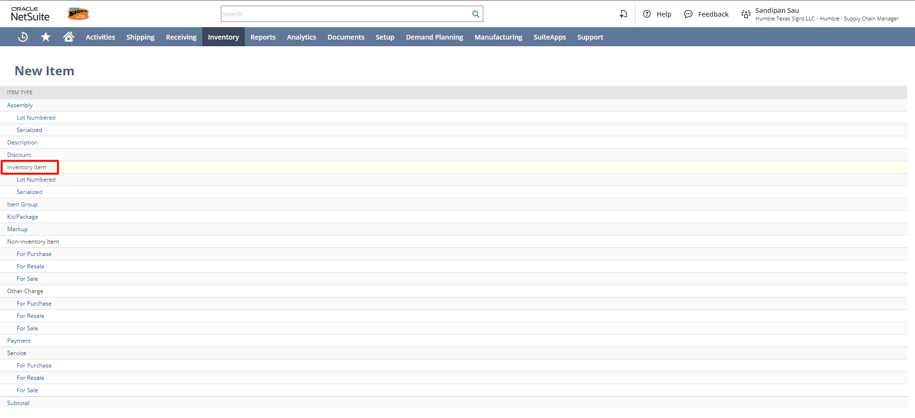
You need to enter Inventory item details such as Item Name/Number, Display Name Code, Unit Type, and Subsidiary. You can add an Item Display Image, Class, Department, Location, Purchase Unit, Stock Unit, and Sale Unit under primary information and classification.
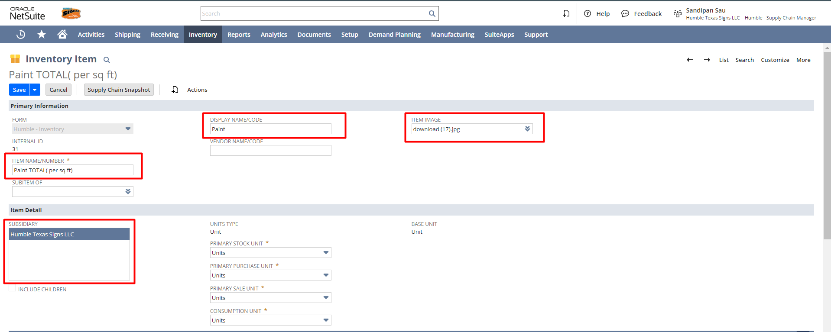

Under the Purchasing/Inventory subtab
- Select the Costing method which is mandatory and once selected you cannot change it after saving the record. As per the discussion, the costing method will be Average.
- Select the cost category as Default.
- You can put the Purchase description and purchase price for the item.
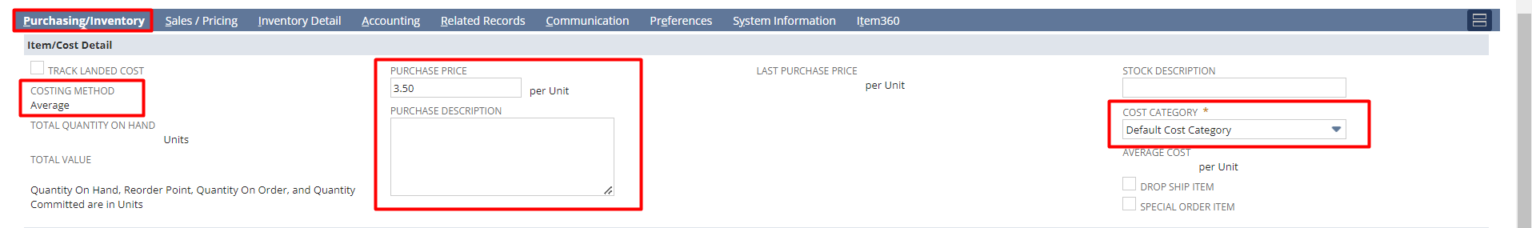
- If you have multiple locations, then you can specify the attributes for that item that are specific to each location. However, for one location it will get the default one, which you mentioned in the Item/Cost Details subtab.
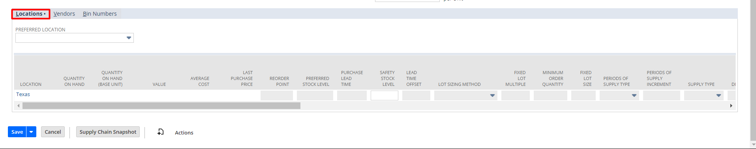
- If you buy this item from multiple vendors, there is an option to define vendor specific pricing for this item. When a Purchase Order is raised with the vendor, the default price defined here would be the default rate for the item on Purchase Order (user can modify if required).
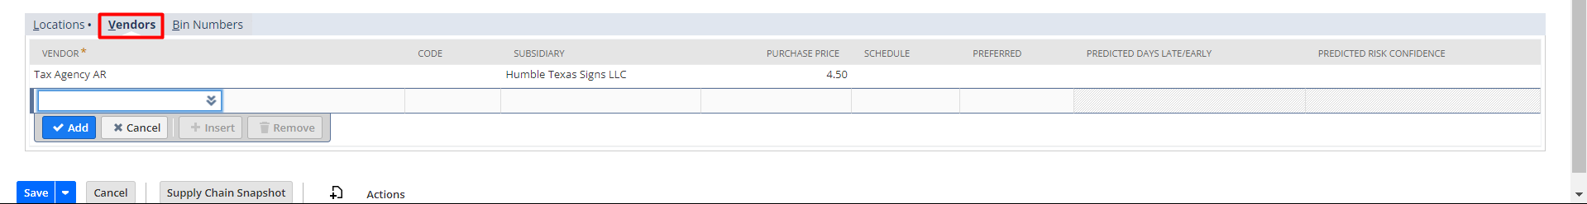

Under the Sales/Pricing subtab
- Enter Sales Description under the Sales Description field.
- Under price level you can set the Base Price in the Item record. The base price will auto-populate in the transaction when you select this item. You can also override the base price in the transaction.
- You can also track quantity-based pricing. In the base price, you can offer different prices.

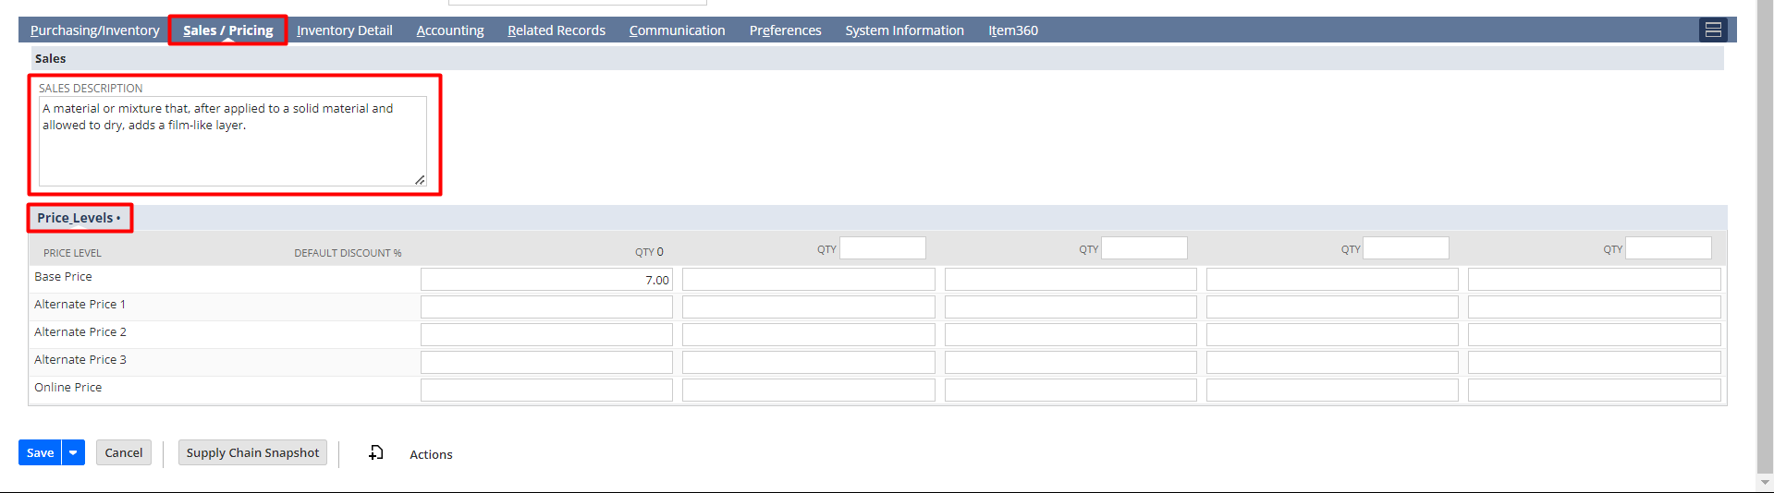
Under the Accounting subtab
- Select the COGS Account, Asset Account, and Income Account, and Tax Schedule from the dropdown list.

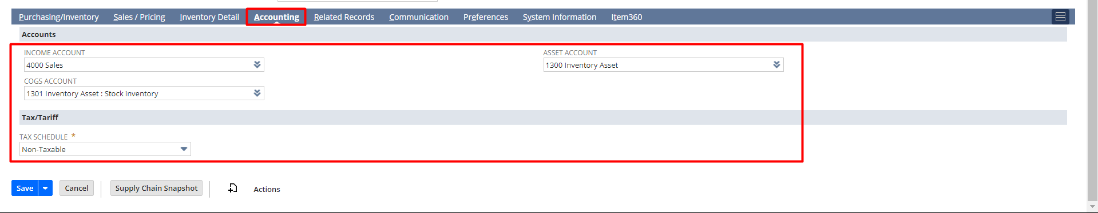
Under the Related Records subtab, you will find all transactions related to this item.

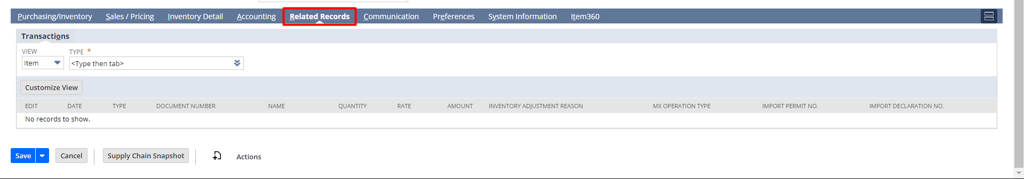
Use the Communication subtab
- To create and send messages to your vendors. You can also create tasks, events associate with a particular Vendor for this Item.
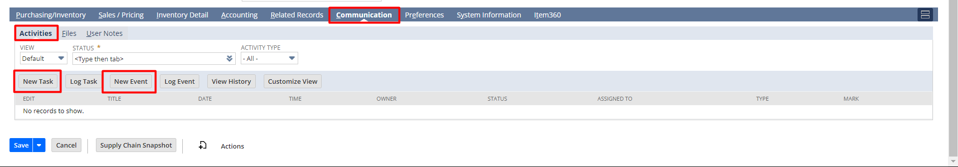
- You can also attach documents in the File Cabinet for the Item using the Activities tab Communication subtab.
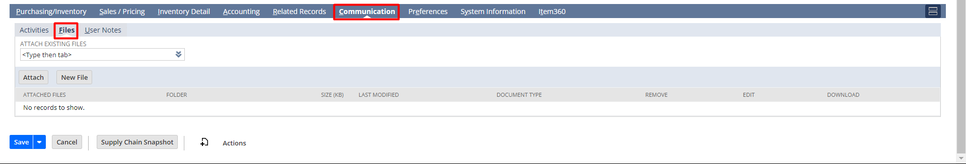
- To add any sort of information or to add any note click on New Note under the User Notes tab.
Under the Preferences subtab you can check the Offer Support checkbox to offering support for item.
Under the System Information subtab,
- To inactive the Item record check the Inactive checkbox.
- You will find a list of system notes under the system notes sublist. This tab can be reviewed to track any changes made by any user on this item record.

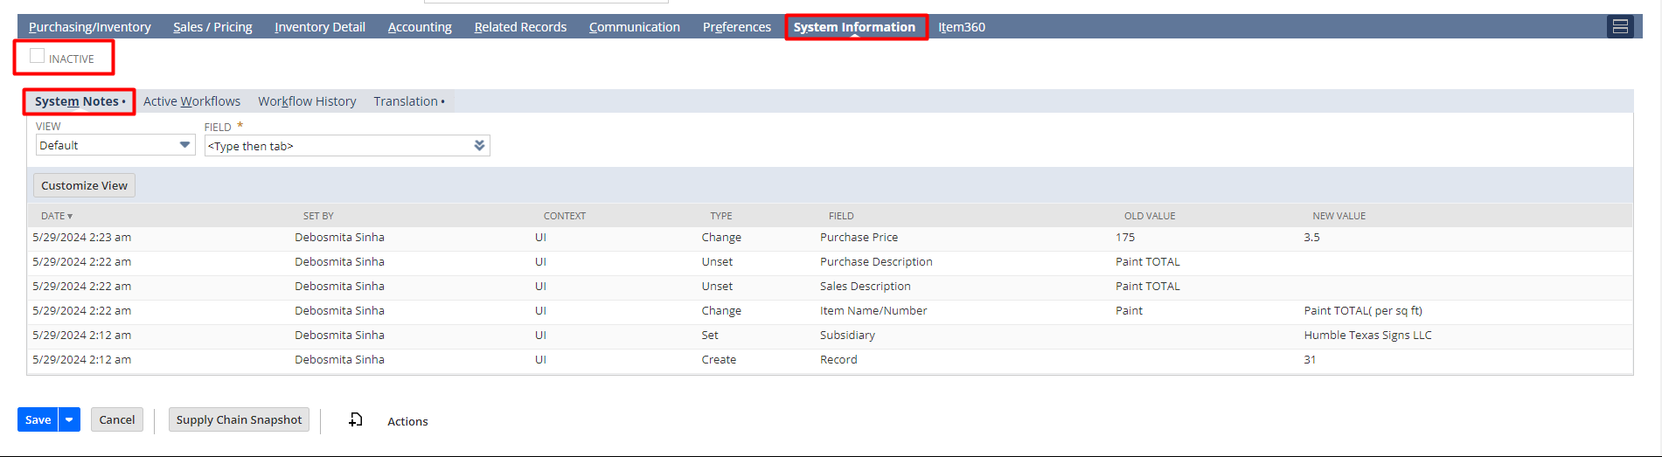
The Item360 subtab provides a real-time and concise overview of an item’s current status.
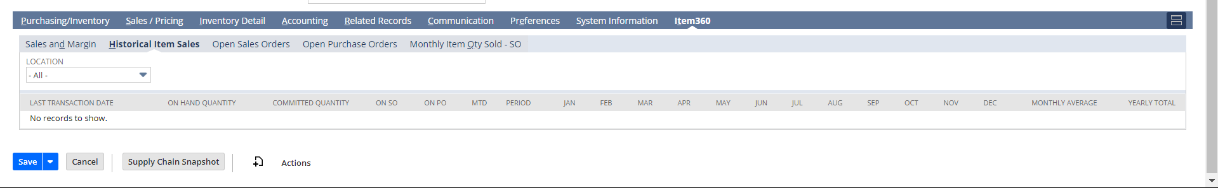
After fill all the details click on Save button to save the Item into the system.
Note: Since the Production Manager is responsible for creating BOM, BOM revision, and routing So the Assembly Item will be shown from the Production Manager role.
Login to Role: Production Manager
Assembly Item Creation:

To create a new Assembly Item, go to the New Item Creation list (Inventory -> Lists -> Items -> New) and select the Assembly Item.
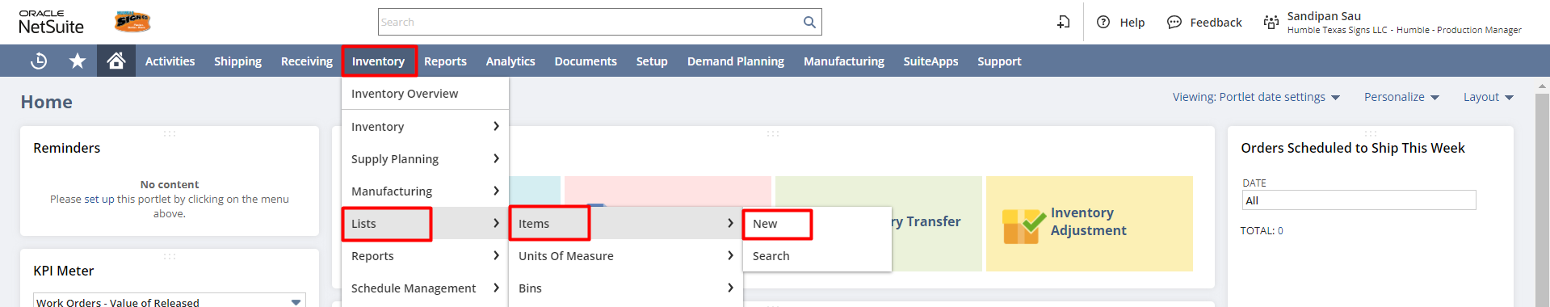
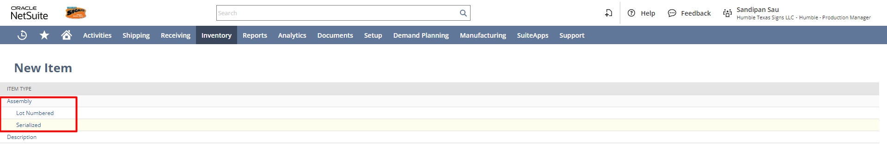

An assembly item is an inventory item made of several components, but identified as a single item. Assemblies are manufactured by combining raw materials you stock.

You create assembly item records to define the members of an assembly, and then NetSuite enables you to track both the raw materials and the assembled items separately.
The components may be an inventory item, a non-inventory item, or an assembly item (sub-assembly) itself.
The user needs to enter assembly item details such as Item Name/Number, Display Name Code, Unit Type, and Subsidiary. You can add an Item Display Image, Class, Department, Location, Description, Purchase Unit, Stock Unit, and Sale Unit under primary information and classification.
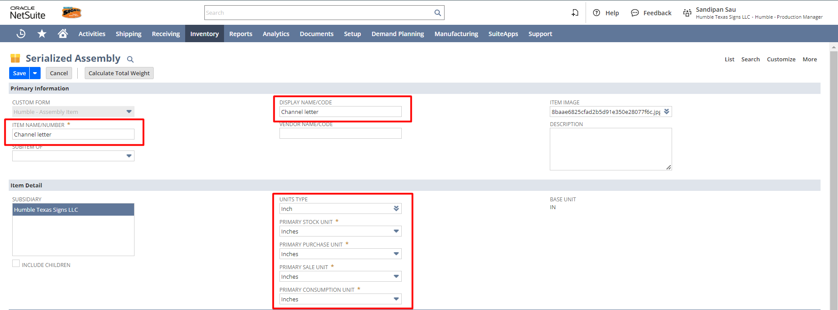
Under the Purchasing/Inventory subtab
- Select the Costing method which is mandatory and cannot be changed once the item record is saved. As per the discussion, the costing method will be Average.
- Select the cost category as Default.

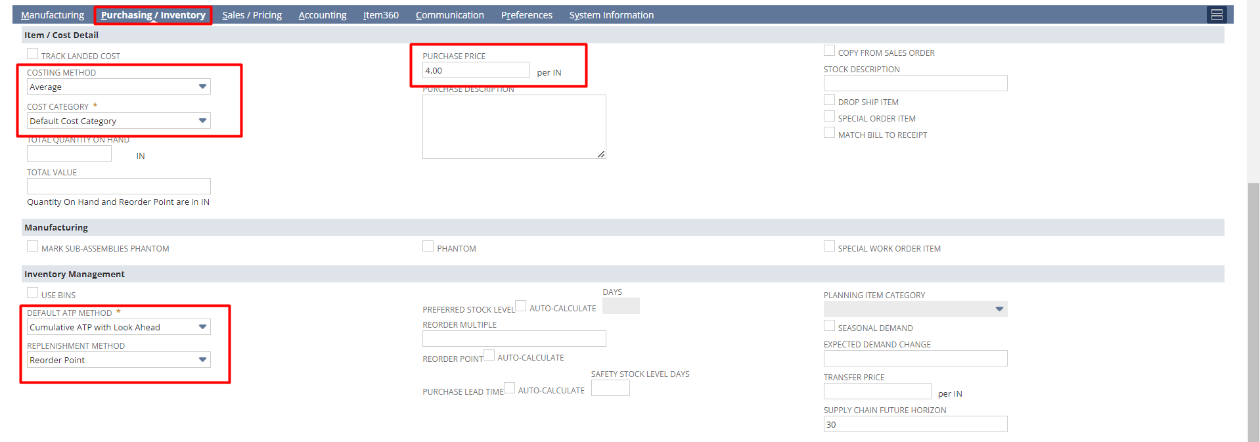
Under the Sales/Pricing subtab:
- Under price level you can set the Base Price in the Item record. The base price will auto-populate in the transaction when you select this item. You can also override the base price in the transaction.
- You can also track quantity-based pricing. In the base price, you can offer different prices to a customer based on the quantity ordered. You can use the alternate pricing also.
- You can also add the Shipping Cost or Handling Cost for that Item if applicable.
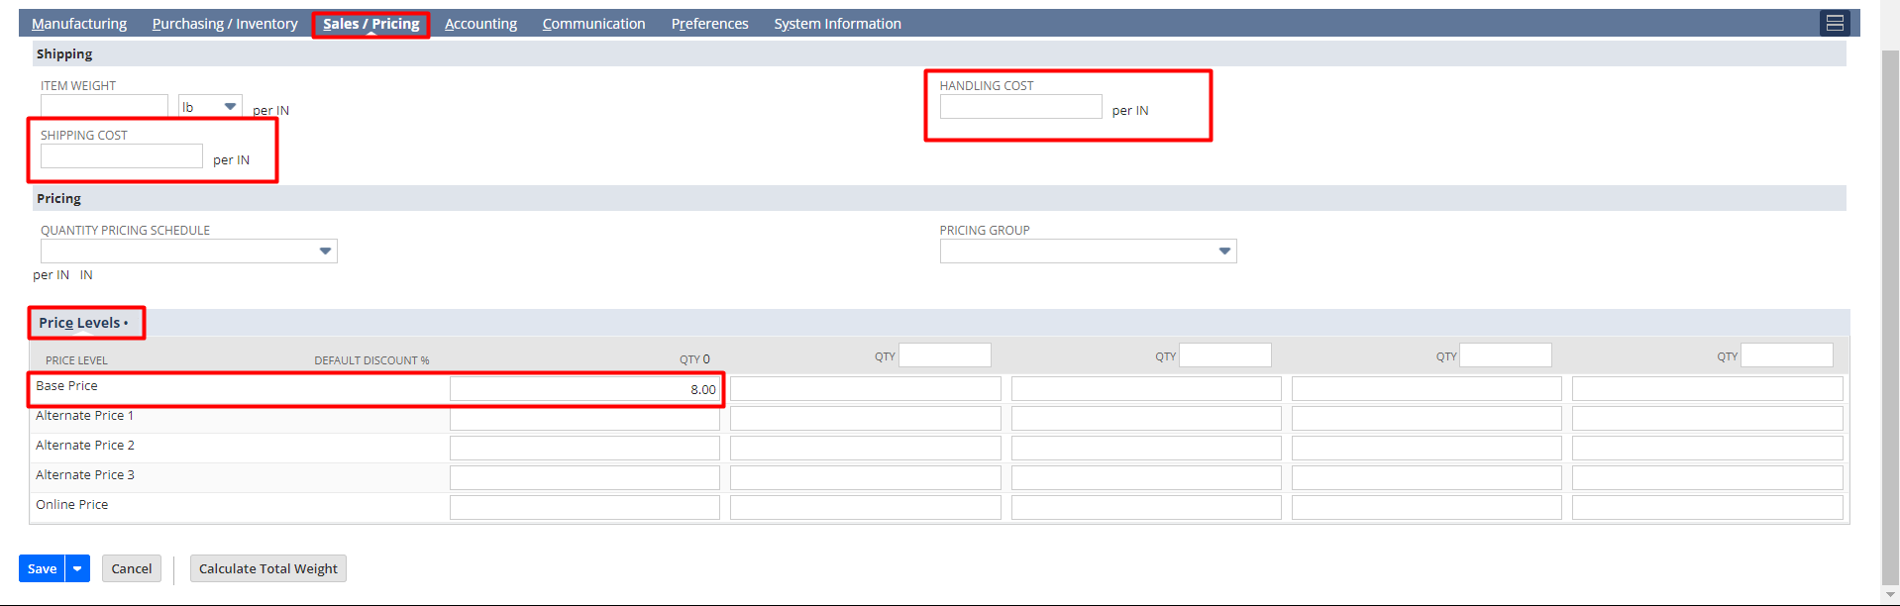
Under the Accounting subtab: The user needs to select the COGS Account, Income Account, Asset Account, Scrap Account, WIP Account, and Tax Schedule.
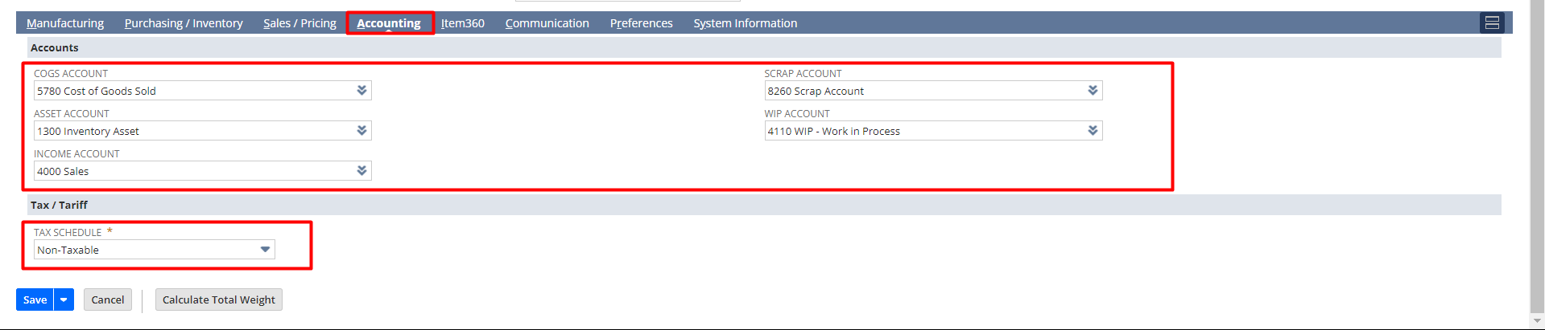
Under the Manufacturing subtab, in Bill of Materials, the user can select an existing BOM or click on the + button to create a new BOM for that Item and the current revision of the selected BOM will be auto-populated.
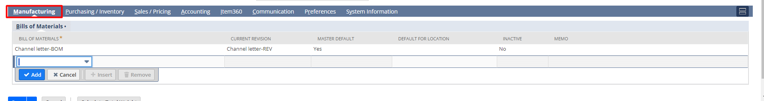
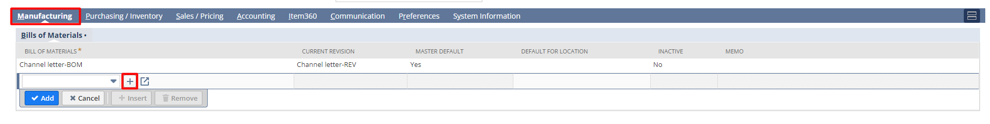

Bill of Materials Creation:

To create a new Bill of Material the below steps are to be followed:
A Bill of Materials (BOM) lists the quantities of raw materials, assemblies, sub-components, and parts needed to manufacture a product. A BOM can be used to communicate between manufacturing partners, multiple facilities within the organization, or with a single manufacturing plant.
In the Bill of Materials Form – The user needs to provide a name to the BOM (It is suggested to name the BOM as the Assembly item suffixed by the word BOM, check the Available for all locations checkbox, and the Available for all Assemblies checkbox if this BOM is to be used for all Assemblies. To restrict it to a particular assembly, uncheck the button and select the particular assembly that will be associated with the particular BOM.
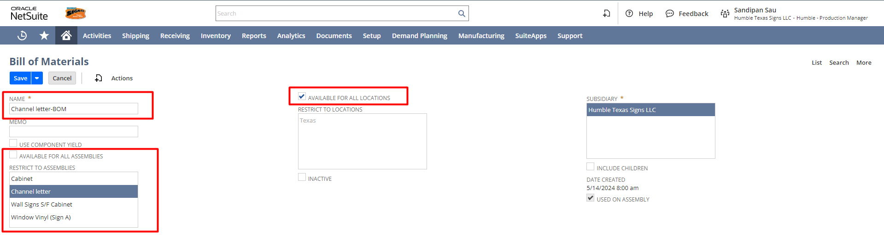
Under the Assemblies subtab: User can find the Assembly Item for which this BOM is belong to.
BOM Revision Creation:
A BOM revision enables you to update a BOM’s details throughout the product lifecycle. A BOM revision also provides an accessible revisions history. Use revisions to compare and track cost savings when many BOM revisions are used in production.
Under the Revisions, subtab of the BOM form – Click on the Create New Revision button and a revision form will open where the user needs to add the components of the linked assembly.
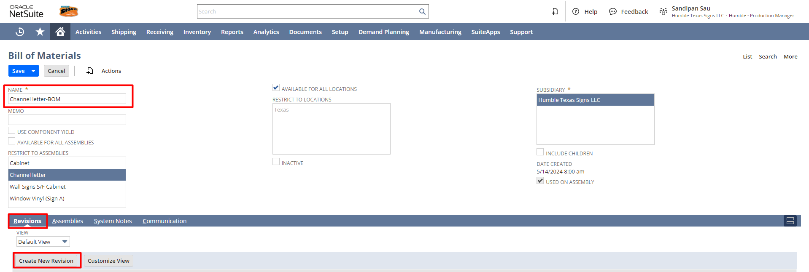
The user needs to provide a name to the revision (It is suggested to name the Revision as the Assembly item suffixed by the word Rev, select the respective BOM associated with it, and fill in other details if required.
You can provide also other details like a memo, effective start date, and effective end date.
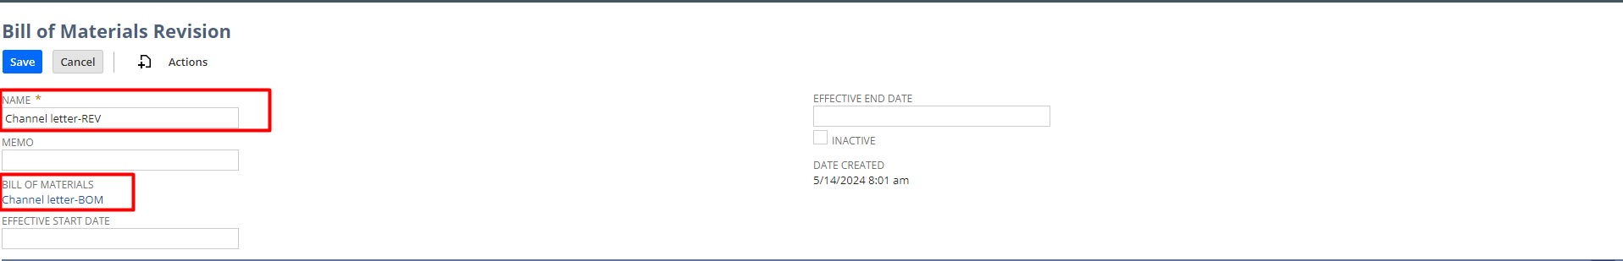
Under the Components subtab – The user needs to select the component name, BOM quantity, Quantity, and Item Source.
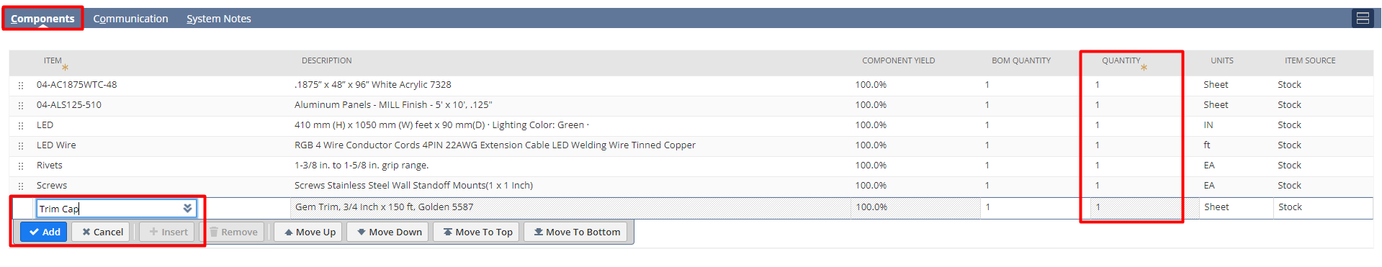
After creating BOM & BOM Revision, Go back to the assembly item record. Select the BOM from the drop down list. The current Revision will come automatically associated with the BOM. Check the master default checkbox.
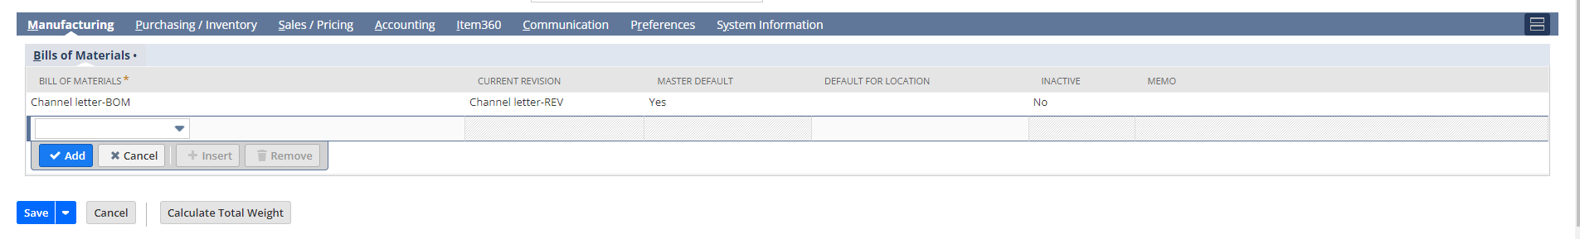

CREATING/UPDATING A MANUFACTURING ROUTING:
Manufacturing routing and Work Center lets you schedule and record manufacturing operational activities against a work order that requires multiple employees, or work centers. For example, you may have a set of operations for the following: a preparation team, an assembly run team, and a quality assurance team.
You can use the Manufacturing Routing and Work Center feature to record quantity assembly completions and team resource costs. You can also use it to process overhead costs against individual work order operations.
In the manufacturing routing user can define the list of operations involved in manufacturing the Assembly. Additionally, the user can also define the cost involved in each operation along with estimated setup (time that is independent of quantity and is a fixed cost for completing the operation) and run time (time that is dependent on the quantity being manufactured and varies as per work order quantity). Please follow the prerequisites below before creating a manufacturing routing.

STEP 1: Cost Categories
You can create a cost category to use the Manufacturing Routing and Work Center feature. Cost categories help define expenditures associated with a work order. For example, you have a warehouse and employ workers to assemble widgets that you sell. You need to track costs associated with employee labor, warehouse machines, and overhead associated with each work order.
You can create one of the following eight cost categories to help track costs:
- Direct Cost – These Costs are calculated when you record time for these items.
- Labor Setup – Cost of time for labor to set up a run.
For example, this is the cost of paying an employee to set up the machine that will be used to paint the widget.
- Labor Run – Cost of time for labor to run an assembly.
For example, this is the cost of paying an employee to use the machine that paints the widget during the assembly run.
- Machine Setup – Cost of time spent to set up a machine to be used in a run.
For example, each time you set up the machine that paints the widget, wear and tear costs you .02 cents.
- Machine Run – Cost of time spent to run a machine during assembly.
For example, each time you use the machine that paints the widget for an assembly run, wear and tear costs you .04 cents.

- Overheads
- Labor Setup Overhead – Cost of overhead associated with labor to set up a run.
- For example, this is the safety training expense incurred for an employee who sets up the machine used to paint the widget.
- Labor Run Overhead – Cost of overhead associated with labor to run an assembly.
- For example, this is the safety training expense incurred for an employee who completes an assembly run.
- Machine Setup Overhead – Cost of overhead associated with setting up a machine used in a run.
For example, this is the water expense incurred by running a machine during the machine setup.
- Machine Run Overhead – The cost of overhead associated with running a machine during assembly.
For example, this is the water expense incurred by running a machine during an assembly run.

Navigation to create a new Cost Category: Setup -> Other Setup -> Accounting Lists -> New

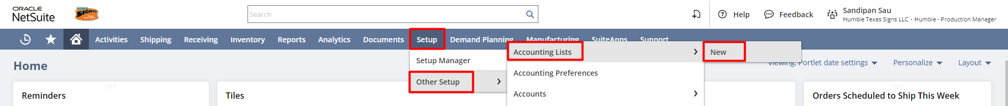

Click Cost Category, then enter the Name of the Cost Category, select the Cost Type and click on Save

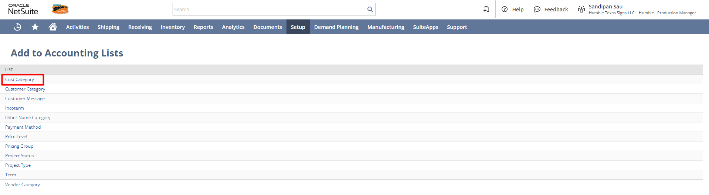

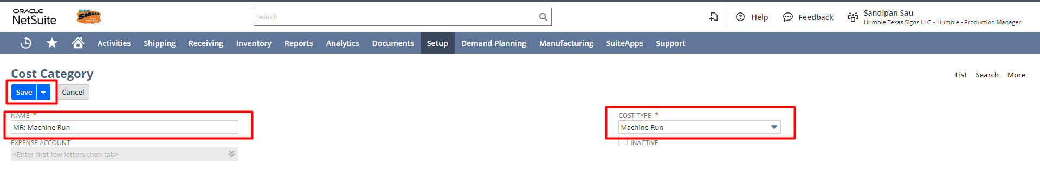

STEP 2: Creating Other Charge Item for Purchase (Manufacturing Charge Item)
With Manufacturing Routing and Work Center, when a specific routing operation is recorded, you can use items to define charges for the activity. For example, you can define the hourly cost of activities being performed, and the expense account the charges are logged against. To do so, you must set up the item record to define the item as a manufacturing charge item.
Navigation: Inventory ->Lists -> Items -> New.
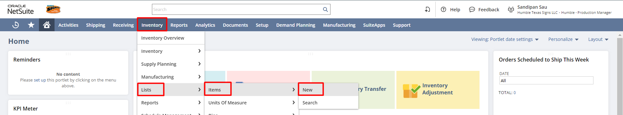
Click on For Purchase under Other Charge.
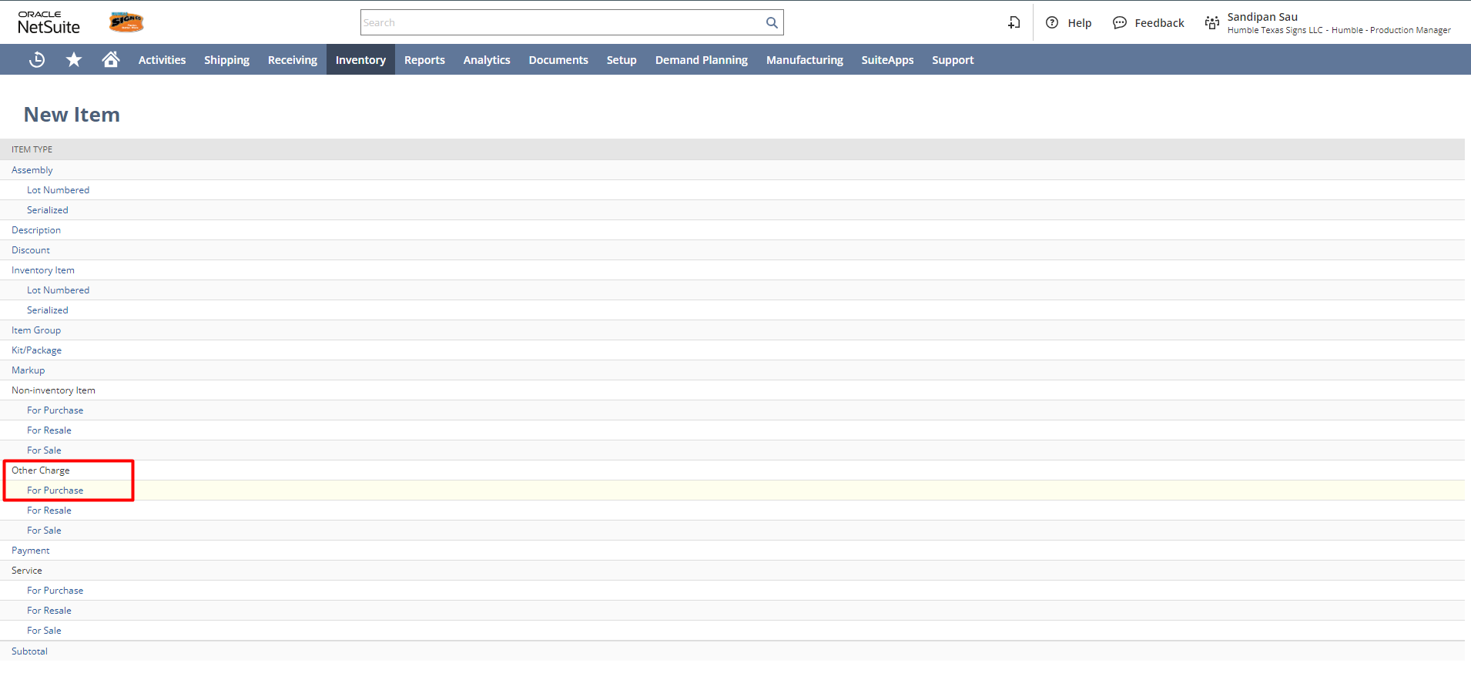
Fill the following details: Item Name/Number
Under the Purchasing tab:
- The “Manufacturing Charge Item” check box needs to be checked.
- Select the Cost Category associated with this Manufacturing Charge Item
- Enter Purchase Price per hour
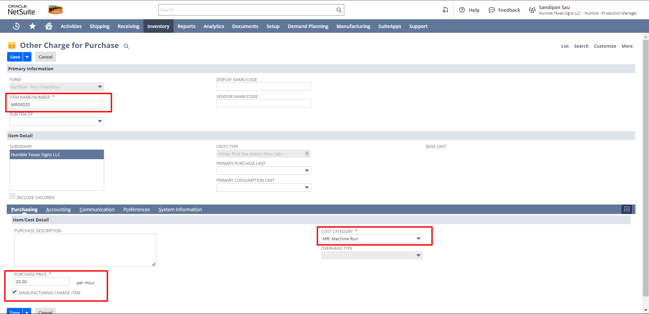

Under Accounting tab:
- Select the Expense Account.
- Select Tax Schedule.
Click on Save
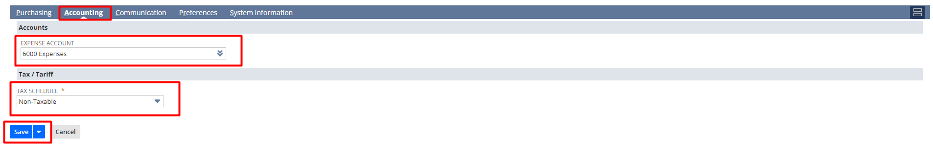

STEP 3: Creating Manufacturing Work Center
A group is a set of employees, contacts, customers, partners, or vendors. You can create groups of records to communicate with a set of individuals.
Navigation to create a new Manufacturing Work Center: Dashboard -> Tiles -> Groups -> New

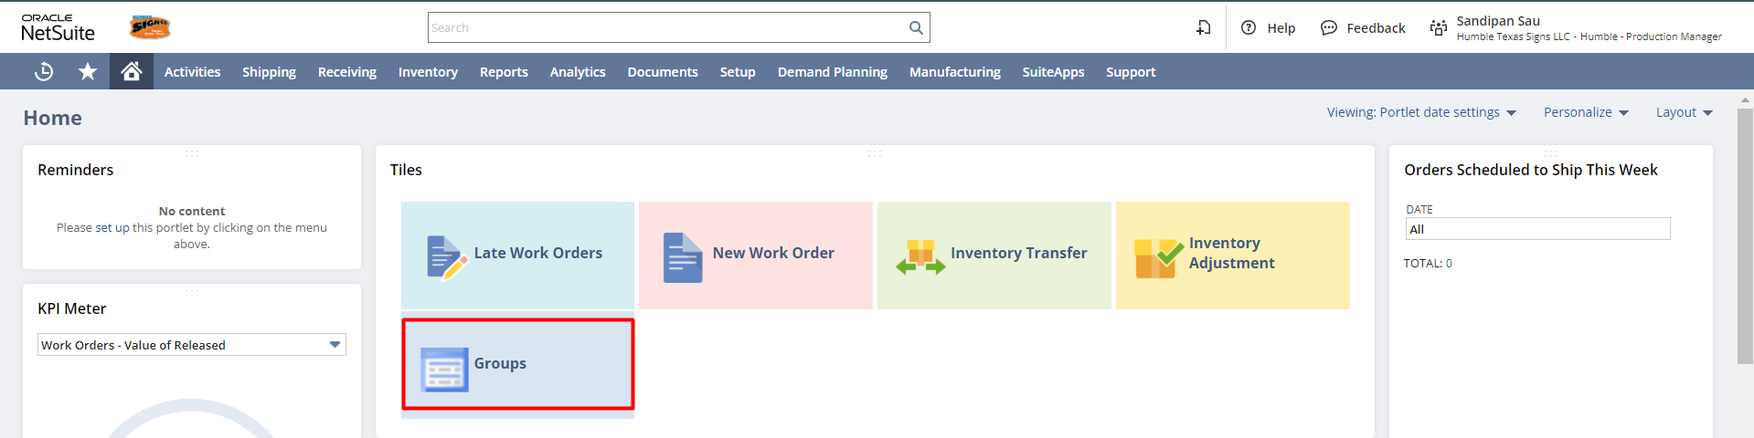

- Select Static as the kind of group.
- Select Employee as the kind of member.
- Click Continue.
- On the Create Static Employee Group page, enter a name for this group.
- For example, enter the Cutting Work center. This name shows in work center lists on records and forms.
- Select the owner of this group.
Note: You are selected by default. Only the owner of a group can add or remove members or delete the group.
- Check the Manufacturing Work Center box. This enables this group to be used as a work center with routing records.
- Click the Manufacturing Work Center Settings subtab.
- Select one or more locations to associate with this work center.
- Enter the number of machine resources for this work center.
If this machine is used in multiple work centers, enter a decimal amount. For example, if this machine is used by another work center for half the day, enter 0.5.
- Enter several labor resources for this work center.
If labor is used by multiple work centers, enter a decimal amount. For example, if a welder spends only two hours in this work center in a day, enter 0.25.

- Complete any additional fields necessary for this group record.
- Click Save.

NetSuite uses the associated work calendar to schedule the operational tasks associated with each work center.

To create a new group, click on the New Group button.
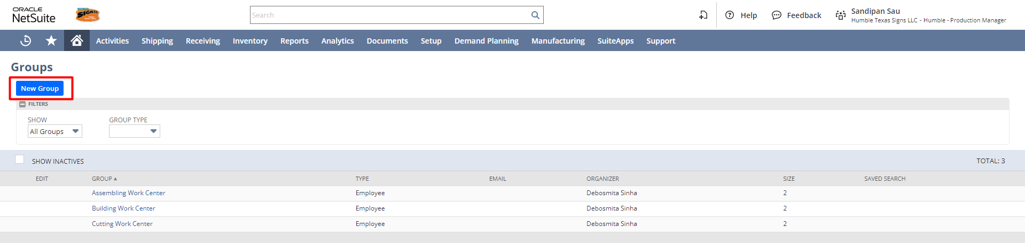
Select Static and Employee as members to include -> click on Continue
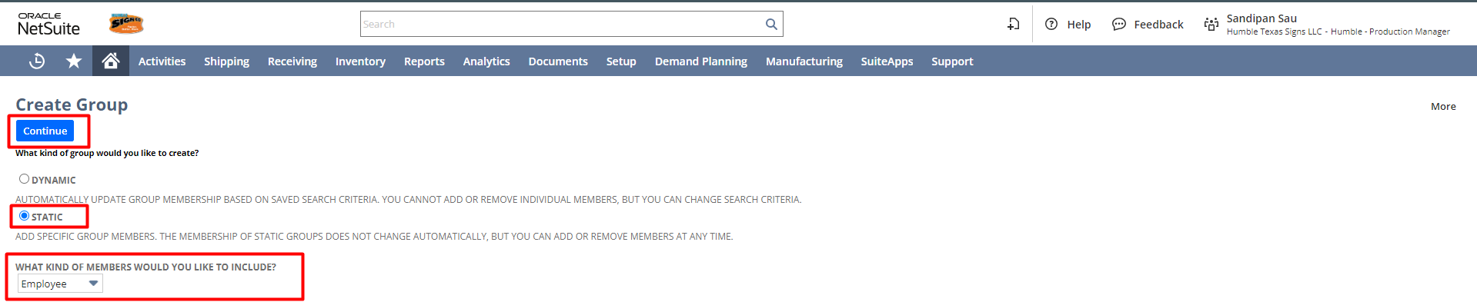
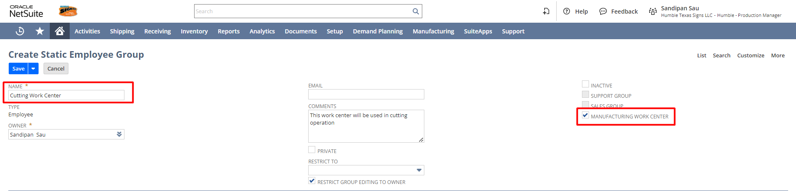
Under the Manufacturing Work Center Settings, enter the Subsidiary, Labor, and Machine Resources required and set the work calendar and then click on Save.

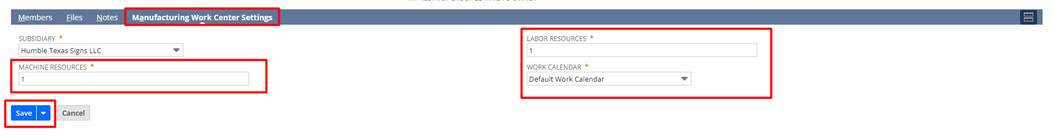

STEP 4: Creating a Manufacturing Cost Template
A manufacturing cost template is a list of rates that can be associated with completing a specific operation. The template defines the activities that occur and related costs to be recorded each time this step is completed.
For example, an employee works 10 hours on an assembly activity. A manufacturing operator needs to record the hours worked as a completion for this step. The cost template defines costs associated with the step completed: the rate for each activity, and what accounts these amounts should post too.
Navigation: Inventory -> Manufacturing -> Manufacturing Cost Templates -> New
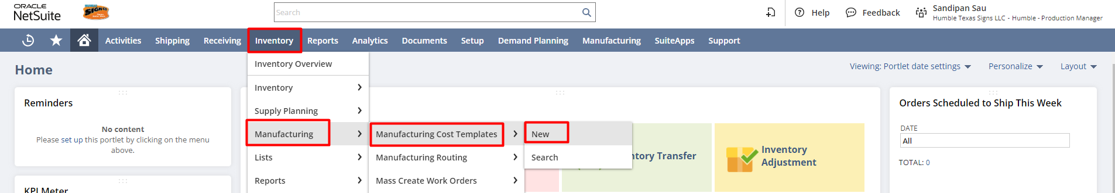

Select/Enter the necessary details:
- Name and Memo
- Select a Cost Category.
- Based on the selected cost category, select the charge item as created in the previous step.
- Run Time/Fixed Time will show the fixed cost/Run Rate per hour for the selected charge item.
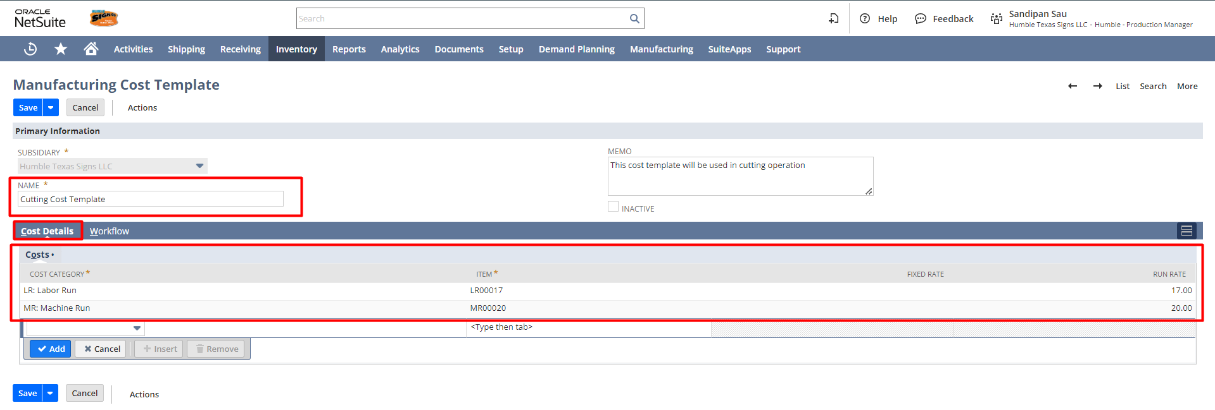
Click on Save.
Create Cost Templates for each operation
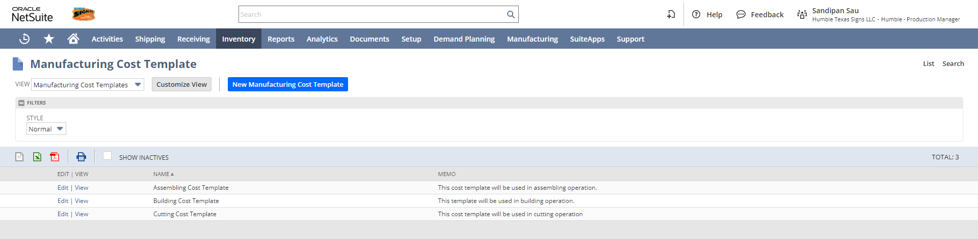

STEP 5: Creating Manufacturing Routing
A manufacturing routing is a template that contains a list of steps required to build an assembly item. Each step is in the order necessary to complete the operational sequence for completing the assembly.
After you create a routing record, that routing can be selected on a work order to direct the completion of the assembly. The routing determines the work center, cost template, labor resources, and machine resources that will be used during the assembly.
From the Production Manager’s Role, Navigation: Inventory -> Manufacturing -> Manufacturing Routing -> New
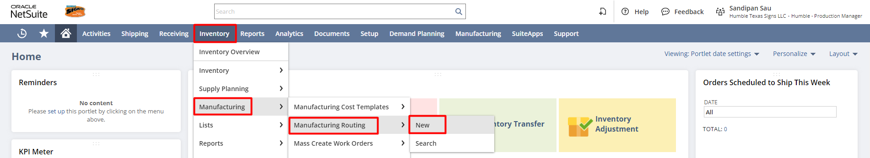
Or,
To attach the Manufacturing Routing in the assembly item-
Under the Manufacturing Routing subsists, click on the New Manufacturing Routing button.

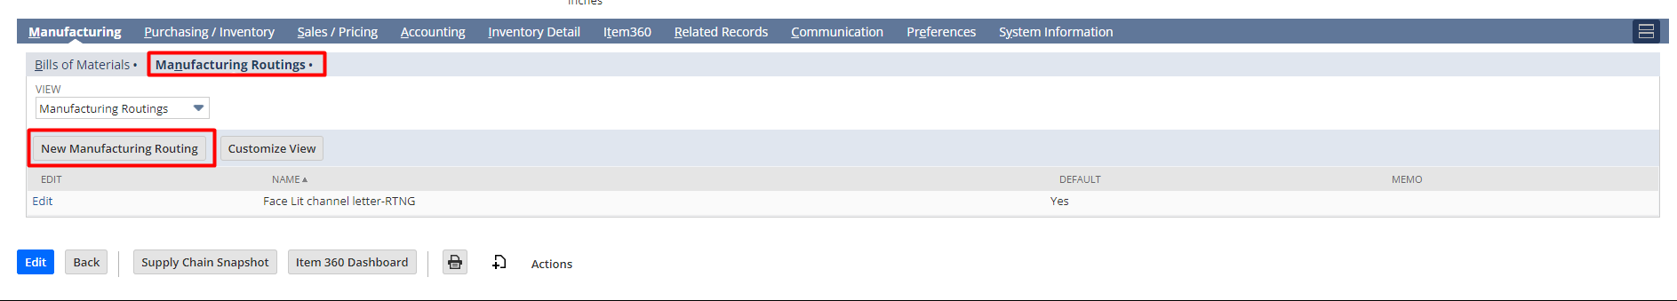

Steps for creating Manufacturing Routing:
- Select Subsidiary
- Select BOM
- Select Location
- Enter Name
Under the Routing Steps Tab,
  - Enter the Operation Sequence number for the step you are entering.
For example, if you are entering the first step to be performed to build this assembly, enter 1. The sequence number determines dependencies between different operations. For example, operation 1 comes before operation 3 in the assembly process.
  - Enter the Operation Name.
For example, enter Assembly Setup.
  - Select a Manufacturing Work Center. This is the labor team that will complete this step.
After you select a work center, the labor resources and machine resources are automatically entered from the work center record.
  - Select a Manufacturing Cost Template for this operation.
  - Enter the operation Setup Time in minutes.
This is the amount of time required (fixed time per step) to prepare for this step in the sequence. For example, this could represent the time in minutes required to warm up a molding machine to bring the mold to the proper temperature. There is one setup time per order.
  - Enter the operation Run Rate in minutes.
This is the amount of time required to complete a run and produce one unit.
  - NetSuite uses the Setup Time, Run Rate and the default calendar to schedule the completion of each step for work orders using this routing.
  - If you use the Demand Planning feature, NetSuite uses backward scheduling to determine the appropriate start date. There is one run time per base unit.
  - The Setup Time + Run Rate = total manufacturing task time
Click on Save.
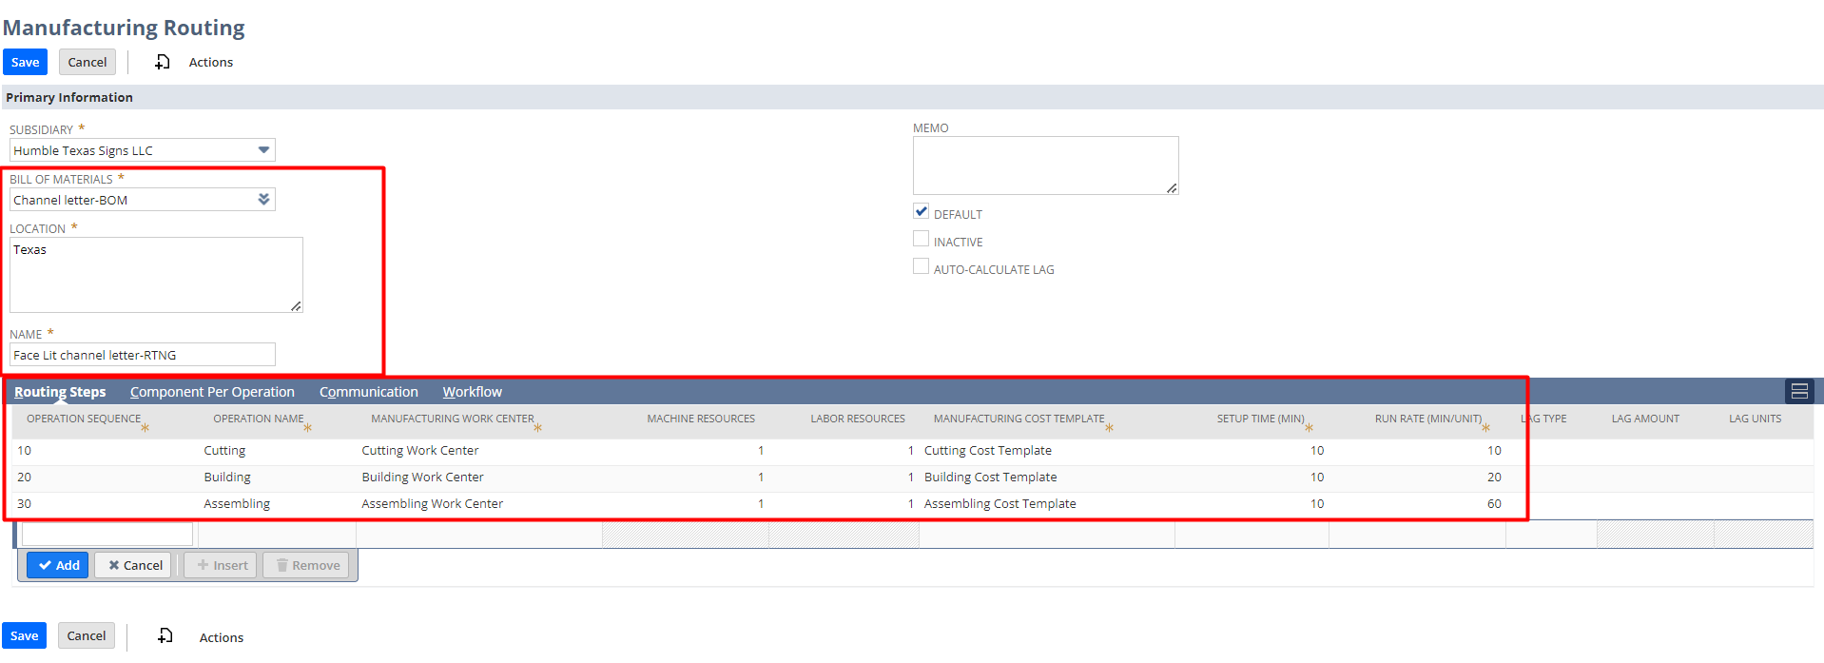

Signature: ________________________________
Date: _____________________________________

Disclaimer:
Upon signing off on the process flow document, you are confirming that the process has been set up per the SOW within NetSuite per your business's needs. Any changes or modifications requested after sign-off will need to be a "change request" at an additional fee.

*** PLEASE ensure that you have logged into NetSuite and tested the process prior to signing off on the setup. Paapri requires sign-off on this document prior to moving forward with any additional design meetings.

